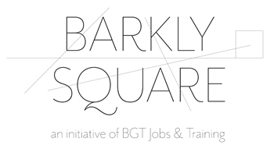
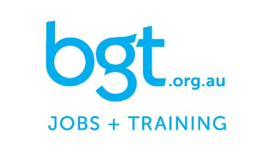

Barkly Square Community & Commercial Kitchen
Booking Application

Thank you for your interest using our facilities at Barkly Square. Please complete this Booking application and email to bookings@barklysquare.org.au well in advance of your requested booking date. Please read the Barkly Square Community & Commercial Kitchen Terms of Use before completing this application; a copy of the Terms of Use can be requested via bookings@barklysquare.org.au or 5333 8600 if not previously received.
Your Details
Individual, group or organisation name

ABN (if applicable)
Primary Contact | Name:  Email:  Tel:
Accounts / Invoicing Email
Individual, group or organisation status | ☐ Not for Profit / Charity (ACNC Registered)  ☐ For Profit organisation or sole trader
Booking Request
Date of Requested Booking
Time of Requested Booking (2 hours minimum hire applies)
Requested use
Expected group capacity
Additional requirements / requests
Supporting Documentation
Have you received the Community & Commercial Kitchen Terms of Use? | ☐ Yes ☐ No
Do you have a Certificate of Currency (Public Liability Insurance) ready to provide? | ☐ Yes ☐ No
Food Business Registration | Must be available upon request
Food Safety Program | Must be available upon request

