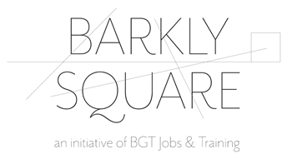

Barkly Square Community & Commercial Kitchen | Terms of Use
25-39 Barkly Street, Ballarat East 3350

- Booking the Barkly Square Commercial Kitchen
1.1 Bookings must be made through BGT (lead tenant / landlord), by email to bookings@barklysquare.org.au or by calling 5333 8600.
1.2 The Commercial Kitchen is available for hire 8:00am – 6:00pm Monday to Friday; with additional days / hours available by agreement. Should you require access outside these standard times please discuss this request at the time of booking enquiry.
1.3 A minimum booking of three hours (in a singular use) will be required to progress a booking.
1.4 The requested booking time must be inclusive of all set up and cleaning / pack up time.
1.5 At the time of booking, BGT will collect the following information (refer privacy statement in this document):
- Individual, group or organisation name
- ABN (if applicable)
- Primary contact information
- Email address for accounts / billing
- A signed copy of these terms of use, in acceptance of the outlined terms.
- Insurance certificate of currency (public liability)
- Safe Work Procedure
- Food Handling and food safety supervision certificate

1.6 Where a booking is made on behalf of an organisation or group, the person making application on behalf of the organisation or group will be responsible for ensuring compliance with these conditions of use.

- Rates of Hire
Prices are subject to change without notice.
Facility | Capacity | Hire Rates: |  | Minimum Booking
Commercial Kitchen | 28 – 55 persons maximum (dependent on density quotients) | Barkly Square Tenants and NFP organisations / groups: | $40 per hour (excluding GST) | 2 hours
 |  | For profit organisations, including sole traders: | $55 per hour (excluding GST) | 2 hours
Additional Cleaning Charge |  | This will be applied if the premises is not returned to original state of cleanliness and hygiene. | $120 (excluding GST) | Single charge

- Payment Terms
The Hire Fee, as determined by BGT and set out above, will be invoiced to the hirer following confirmation of booking. Payment is to be made before the booking date, directly to BGT as per details and terms on invoice. Failure to pay as per conditions may affect future booking requests.
- Booking Cancellations
4.1 The hirer (individual / group / organisation) may request to cancel a booking. An email confirmation of cancellation must be received no less than three business days prior to the hire date(s), otherwise the full hire fee shall be charged. If payment had already been made, a refund / credit note will be provided if the cancellation follows the agreed terms and notice period.
4.2 In extenuating circumstances (including compassionate, health and Covid-related grounds for cancellation), BGT will exercise its discretion in terms of waiving any charges associated with late cancellations (outside notice period).

- Covid-19 safety and requirements
5.1 The Hirer agrees to follow the current Victorian Chief Health Officer's directions
  - The Hirer must ensure that all current vaccination requirements are followed for all persons associated with the hirer attending the facility.
  - The Hirer must ensure that the hire purpose does not exceed the current density quotients or capacity limit of the facility.
  - The hirer will be responsible for ensuring all current Covid-19 guidelines and restrictions are adhered to, e.g. maintaining social distancing and wearing of face masks.
  - BGT recommends that The Hirer / facilitator completes COVID-19 Infection Control Training and reviews the COVID-19 Resource Kit by Fair Work Australia which outlines safety practices by which to abide.
  - The hirer is required to record participants attending, in accordance with Covid-19 guidelines. Each hirer group must:
a) provide a QR code for participants to register attendance at their activity, and/or
b) use the QR code provided by Barkly Square to check in

5.6 All non-permanent kitchen equipment will be provided by the hirer group where possible, encouraging responsibility for sanitisation of equipment and reducing the opportunity for transmission through shared items.
5.7 BGT reserves the right to request a copy of the hirer’s Covidsafe Plan at any time leading up to or following the booking.
5.8 In the event of a Covid-19 lockdown or restricted movement order, the use of the Commercial Kitchen will cease in alignment with restrictions and only recommence use once planned use / activity is permitted to recommence.
5.9 If the facility closes due to a Covid-19 lockdown, BGT will contact the hirer (giving as much notice as possible) prior to the booking to advise, and to arrange a refund / credit note and the opportunity to reschedule.

- Food Handling, Food Safety Program and Food Business Registration
It is mandatory that each individual / group / organisation seeking to use the Barkly Square Commercial Kitchen has obtained the necessary permits prior to use, in order to comply with all reasonable and legislative requirements of local government, the Food Act 1984 and the Public Health and Wellbeing Act 2008. This may include (but not be limited to):

- food handling and food safety supervision certification
- a recognised / registered food safety program
- registration of the individual / group / business with local government as a food premises
- obtaining a liquor license (if this is applicable, BGT requires a copy prior to the booking)

It is the responsibility of each hirer (individual / group / organisation) of the Commercial Kitchen to obtain and maintain all documentation as required by legislation. To support the Food Safety Program and Commercial Kitchen registration established for Barkly Square, BGT reserves the right to request copies of this required documentation from the hirer (individual / group / organisation) to ensure compliance.
Further information is available via the following links:
- City of Ballarat - application to register a food premises
- Victorian Department of Health - food safety

- Limits of use
  - The hirer shall be entitled to use the specific room hired (per booking agreement) at Barkly Square only i.e. the Commercial Kitchen. BGT maintains the right to hire out or let any other portion(s) of the Barkly Square facility for any other purpose at the same time.
  - BGT reserves the right to refuse booking applications for the Commercial Kitchen e.g. where we are unable to viably meet the requirements of the applicant.
  - No portion of the booked facility may be sub-let, or any booking transferred without the written prior consent of BGT.

- Commercial Kitchen Facilities
The Commercial Kitchen contains extensive commercial grade equipment, use of which is included in hire rates. Included is a plan of the Commercial Kitchen and outline of the equipment available for use.
- If specialised equipment is required for the booking use, this equipment should be brought in by the hirer.
- All required ingredients, materials and food products required are the responsibility of each hirer to source.
- As a general rule, storage of supplies and/or food in the kitchen beyond the period of hire is not permitted.
- Essential cleaning products will be provided to ensure the Kitchen is maintained to a clean and hygienic standard. Cleaning cloths / sponges, tea towels etc. are the responsibility of each hirer to provide, ensuring removal at the end of hire to avoid cross-contamination between uses.
- NB. If bringing in your own kitchen equipment this needs to be safe and tagged.

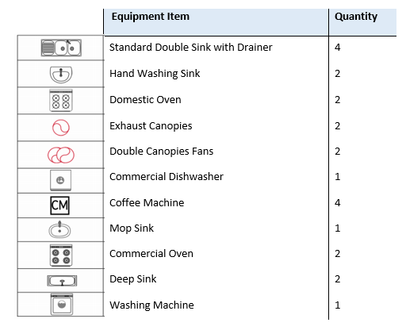
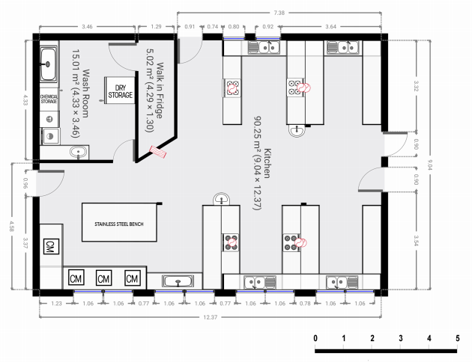
- Condition and use of the facility
  - BGT makes no warranty or representation to the Hirer about the condition of the facility in terms of suitability for the hirer’s purpose.
  - The hirer acknowledges that they have inspected the facility and / or determined it is suitable for the hirer’s purpose.
  - The condition of the Facility should be left in the same condition as the Hirer found it, noting cleanliness and hygiene requirements for a food premises.
- Equipment is to be returned to original locations.
- All rubbish and food scraps are to be removed and disposed of appropriately.
- All surfaces, appliances and equipment used are to be wiped down.
- Floors in areas of use are to be swept / mopped.
- All items belonging to the hirer removed from the premises, including food and drink items from cold and dry storage. BGT accepts no responsibility for private property left on the premises.
- Doors and windows are to be closed upon exit.
- Key / swipe card must be returned to BGT Reception (if applicable).
  - No disorderly behaviour or damage to property shall be permitted in any part of the facility. BGT reserve the right to remove such offenders, with the hirer to pay any costs associated with the removal of these offenders.
  - Should any damage occur during the course of booking, liability for this cost will rest with the hirer (see also insurance).
  - Smoking is not permitted in the facility. There is one designated smoking area on external grounds (which can be shown to the hirer if needed); this is the only permitted location for smoking on the premises.
  - As documented in the Commercial Kitchen rates of hire, an additional cleaning fee will be issued to the hirer if the facility is not left in its original state of cleanliness and hygiene, and in a condition complying with these terms of use. If excess damage or cleaning costs are incurred beyond the standard cleaning fee, this will also be passed onto the hirer to pay.
  - The assessment completed by BGT of the premises condition at the conclusion of hire period shall be final.
  - Property, structural elements and capital equipment within the premises remain the responsibility of the landlord (BGT, lead tenant) to maintain. If any property or equipment defect is noted during the booking, please report this as soon as practicable to BGT on 5333 8600 or admin@bgt.org.au.

- Emergency Management and Safety Protocols
  - All persons using Barkly Square facilities are required to comply with BGT / Barkly Square Emergency Management and Evacuation Procedures.
  - A site induction and overview of evacuation procedure will be provided by a member of BGT administration team prior to booking; emergency evacuation information will also be on display inside the facility / kitchen.
  - The hirer is required to follow all safe work practices established by BGT for use of the Commercial Kitchen.
  - The hirer will provide an emergency contact to BGT at the time of booking / accepting terms of use; this person will only be contacted in an emergency situation if the hirer is unwell, injured or otherwise adversely affected and a contact needs to be notified.
  - The hirer permits BGT (its employees or agents) to contact emergency services should this be deemed necessary, including consent to ambulance transport if required.
  - The Commercial Kitchen is fitted with all required essential safety measures, including smoke detection system, fire extinguisher and fire blanket(s); these measures are the responsibility of BGT to maintain.
  - The Commercial Kitchen has a standard first aid kit available, regularly audited to ensure adequately stocked. A fully stocked first aid kit is also available to all ground floor tenants / hirers, located within BGT Reception. These first aid kits are the responsibility of BGT to maintain.

- Disputes
In the event of any dispute or difference arising as to the interpretation of these terms of use or any matter contained therein, the decision of BGT shall be final and conclusive.

- Insurance and Indemnity
  - The hirer (individual / group / organisation) must take out Public Liability Insurance. The hirer must supply a certificate of currency for their public liability insurance to BGT, prior to the booking.
  - Except to the extent of any negligence or deliberate act by BGT or its agents or employees, the hirer is responsible for any accident, loss or damage sustained, to any person or property, which occurs in the hired facility during the period of booking. The hirer releases and indemnifies BGT, its agents and employees, from all claims and demands made in connection therewith. This includes (but is not limited to):
- Any legal liability whatsoever arising from participation or use by the hirer, and/or any other persons associated with the hirer, and/or the activity connected with use of the facility;
- Any and all loss, damage, expenses, claims whatsoever which might be sustained or asserted by any person or body for injury, loss or damage arising in any manner during participation or use of the facility;
- All loss or damage to any property, buildings, equipment or materials of BGT and Barkly Square and/or any other persons on or outside the premises caused by the hirer and/or any persons associated with the hirer due to the stated participation or use; and
- Any and all loss, damage, injury or illness sustained by the hirer and/or any person associated with the hirer arising in any manner from the participation or use of the hired facility.

- Privacy
BGT collects information in accordance with State and Federal privacy and data protection laws, which regulate the collection, use and disclosure of personal information. In this context, BGT collects information for the purpose of:
- processing and managing the enquiry, application and booking to use the facility
- for regulatory, safety or other lawful purposes
- for operational / management requirements of BGT and Barkly Square
- to assist BGT in improving our services to the community.

- Agreement and Declaration
See over.

14. Agreement and Declaration

I have read, understood and agree to all the terms of use outlined in this document. I understand that if BGT accepts my booking request, the information I provide and these acknowledged terms of use form an agreement between BGT and the hirer.
I understand that if I fail to adhere to these terms of use, my ability to use the Barkly Square facilities on future occasions may be jeopardised. I fully understand that when using the Barkly Square Commercial Kitchen, I may only use the premises at the agreed dates and times, as confirmed with BGT.
I am aware that any people that use the facility as a part of my booking with BGT are directly my responsibility.

Hirer (Print Name): __________________________________________________________

Signature: ______________________________________ Date: Click or tap to enter a date.

Individual, group or organisation name

ABN (if applicable)
Primary Contact | Name:  Email:  Tel:
Emergency Contact (per section 10) | Name:  Email:  Tel:
Mailing Address
Accounts / Invoicing Email
Signed Terms of Use | Provided: ☐ Yes ☐ No
Certificate of Currency - Public Liability Insurance | Provided: ☐ Yes ☐ No
Food Business Registration | Must be available upon request
Food Safety Program | Must be available upon request

